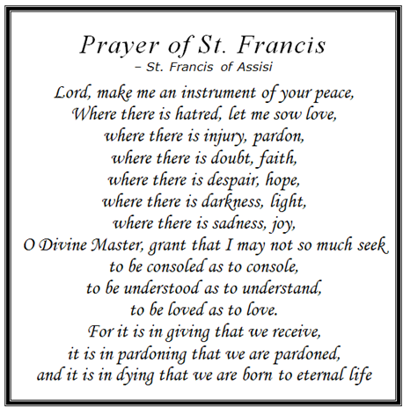
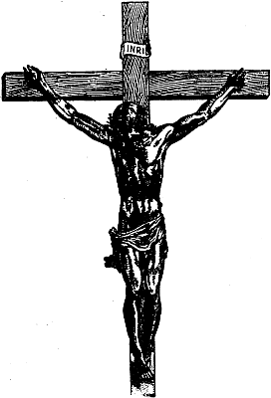
“If I speak in human and angelic tongues, but do not have love, I am a resounding gong or a clashing cymbal.
And if I have the gift of prophecy and comprehend all mysteries and all knowledge; if I have all faith so as to move mountains but do not have love, I am nothing..
If I give away everything I own, and if I hand my body over so that I may boast but do not have love, I gain nothing..
Love is patient, love is kind. It is not jealous, is not pompous, it is not inflated,
it is not rude, it does not seek its own interests, it is not quick-tempered, it does not brood over injury,
it does not rejoice over wrongdoing but rejoices with the truth.
It bears all things, believes all things, hopes all things, endures all things.
Love never fails.”
1 Corinthians 13: 1-8

